
May 2016 Newsletter
Happy Birthday to all our May babies!!
Congratulations, if you have made it to full Medicare age!!

“I am very, very happy to announce 3 wonderful additions to my website!”

In the heading above you will see a red arrow pointing to new quoting links on the site.
You can now get FREE instant quotes of
Life Insurance, Dental Discounts & Dental Insurance & Vision Insurance plans.
YOU CAN BUY THE INSURANCE DIRECTLY ON THE WEBSITE!
This is what you will see when you go to the Life Insurance Self Service Quote Page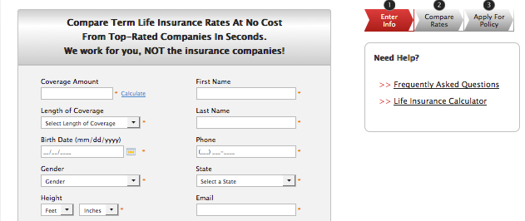
This is what you see on the Dental & Vision Insurance Plan Self Service Quote Page


Many of you have asked for a low cost dental plan by going to the Dental Discounts page you will find the dentist in your area that offer discounts on dental work, it is less expensive than regular dental insurance. Be sure to check out both Insurance & Discount plans to find the one that’s right for your needs and budget.

Pass It On
Financial and Insurance decisions can be overwhelming, but a recommendation from a friend or family member can offer them peace of mind. If you have been happy with my service, pass it on. Please tell your friends and family they can get advice they need by contacting me at
845-380-5809 or going to my website InsuredMeds.com for information. I am always happy to hear from you, don’t hesitate to call me for advice or information.
Have faith in your future!

